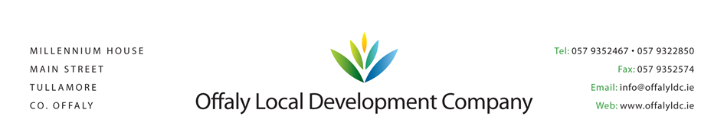

TÚS PLACEMENT PROVIDER – EVALUATION REPORT

Group Name: ______________________________

MANAGER: _________________________
Telephone: _________________________

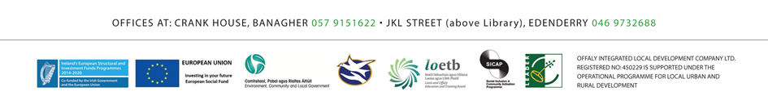

SUMMARY OF EVALUATION CONDUCTED BY OFFALY LOCAL DEVELOPMENT COMPANY
CHECK LIST | YYES | NO
Is the application adequately completed?
Does the organisation meet the eligibility rules?
Do they demonstrate active community involvement and service delivery?
Does the proposed work placement meet the requirements of Tús?
Is there existing paid staff in the organisation?
Is the service and work proposed eligible?
Have any staff members been made redundant or let go in past 9-12 months?
Is the work all year round?
Have seasonal factors been taken into account?
Are any costs involved for the Offaly Local Development Company?
Is there a child and vulnerable adult safeguarding policy in place?
Is Garda Vetting required for the post?
Is there adequate public liability insurance in place and has it been inspected?
Are the necessary indemnities available from the work placement provider?
Is a recent safety statement available or can one be easily prepared?
Have health, safety & related issues been examined & determined to be adequate by the IB?
Is lone working an issue with the placement?
Can local monitoring of work be undertaken (via other staff or regular volunteer engagement)
Are the welfare facilities adequate and available (catering, toilet, heating, comfort)?
Have access issues been considered?
Can outputs be quantified?

ASSESSMENT REPORT FROM SELECTION COMMITTEE
Profile of the work

How well structured is the placement – comment on nature of work proposed

Quality of work experience

Will the work be meaningful and provide a good quality experience for the participant

Environment

Comment on the work environment (and if there have been a site visit to meet the proposers) – address any
Health/safety or security/comfort concerns

Costs

To what degree has the placement provider evaluated the costs involved? Can these be sustained
Displacement or deadweight and substitution

Comment on any concerns about displacing workers in the organisation or displacing other workers locally

Other Public Funding

Degree to which work placement proposed will impact other publicly funded activities in the organisation if any

Organisational Policies

Have policies in respect of care and welfare of children & vulnerable adults been inspected & are they adequate?

Organisational capacity

Comment on the organisation capacity of the placement providers, board & management ability/direction/plans

Outputs

What type of outputs and impacts are expected? Will it be possible to evaluate the benefits

Integration with other publicly funded programmes

Comment if other programmes are present (CE, RSS, JI, childcare supports)

Additional comments of the assessor

Overall recommendation to selection committee/board

For and on behalf of Offaly Local Development Company
Signed: ________________________________
Position: ________________________________
Date: ________________________________
Please retain on file for departmental or audit inspections

