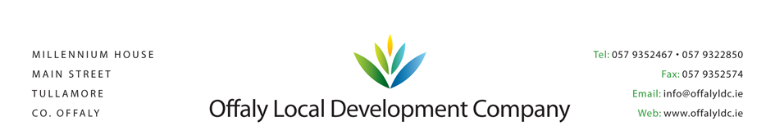

TÚS - PLACEMENT PROVIDER AGREEMENT

2020 - 2021

Group Name: _____________________

MANAGER: _______________
CONTACT NUMBER: ________________

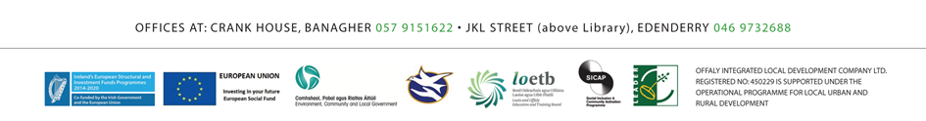
AGREEMENT FOR THE PROVISION OF WORK PALCEMENT FUNDED UNDER
TÚS – the community work placement initiative
AGGREEMENT between
Name of Implementing Body: Offaly Local Development Company
AND
Name of Placement Provider: ______________________________

Introduction
Tús is an activation initiative for those who are unemployed and on the Live Register. Tús will provide short-term quality and suitable working opportunities for people who are unemployed while at the same time carrying out beneficial work within communities, and will contribute to the management of the Live Register.
As an organisation providing a work placement, you are required to agree to the terms and conditions (see below) relating to the provision of work placements to participants under Tús – the community work placement initiative.
In addition we aim to work with you to provide a positive work experience for each participant that reflects their skill level and ambition. The work to be undertaken must continue to be structured, meaningful, support work experience, and enable your organisation to provide improved or extended services. It is essential that these be demonstrated. We are required to provide feedback on a person’s performance and to evaluate the work that has been undertaken and the participants conduct on it.

Terms and Conditions applicable to the Placement Provider Agreement
Work placements will be terminated if the work placement provider has dismissed or made redundant any employees in order to provide a work placement supported by Tús. The work placement will be terminated if such a dismissal or redundancy is subsequently found to have taken place.
1. (The Placement Provider), when agreeing to sign the work placement agreement, is making a declaration that they have not made anyone redundant in order to make room for a Tús participant.
2. Tús participants shall have the right to choose whether or not to be a member of a union.
3. (The Placement Provider), must comply with all relevant legislation and statutory duties in respect of Tús participants, including health and safety, welfare and discrimination at work.
4. (The Placement Provider), will immediately notify Offaly Local Development Company in writing if a participant does not attend work at the times stated, is absent for whatever reason, does not engage in productive activity, causes disruption or is otherwise non-cooperative.
5. (The Placement Provider), shall inform Offaly Local Development Company immediately, in the case of accident or death, and as soon as reasonable/practicable in any case of serious injury or serious illness occurring to the participant arising out of his or her use of the facilities provided by the (The Placement Provider).
6. Offaly Local Development Company reserves the right to terminate this agreement where the terms and conditions of this agreement have not been met or where the nature of the work to be undertaken by the participant are not in keeping with any proposal agree with Offaly Local Development Company. This will not be done without prior discussion between Offaly Local Development Company and (The Placement Provider).
7. Offaly Local Development Company reserves the right to terminate this agreement where;
a) (The Placement Provider) does not make adequate provision for the constructive engagement of the Tús participant
b) The work conditions are such as to give rise to concerns about a participant’s safety or well- being
c) Suitable work is not available
d) (The Placement Provider) ceases trading or providing a service or threatens to do so
e) (The Placement Provider) becomes bankrupt, or goes into liquidation; or a receiver or administrator is appointed over any of its assets
8. Offaly Local Development Company and (The Placement Provider) will review the operation of this agreement annually, or earlier at the request of either party. (The Placement Provider) accepts that this agreement does not represent a long-term commitment by Offaly Local Development Company to support the services provided by Tús participants and that in any event, no more than two years support can be committed to at any one time.
9. As part of its duty to ensure the proper use of public money, Offaly Local Development Company may require (The Placement Provider) to allow access at reasonable times to officials, authorised by Offaly Local Development Company, to inspect any documents or information in respect of participants.
10. A participant will not be based with another organisation, other than as agreed with Offaly Local Development Company.
11. (The Placement Provider) will notify Offaly Local Development Company immediately of any circumstances, which may affect the work placement provider’s ability to provide work during the agreed period of the work placement.
12. (The Placement Provider) is responsible for its own costs and involvement in Tús, there is no obligation on Offaly Local Development Company or the Department of Social Protection to meet costs arising from the work placement.
13. (The Placement Provider) is responsible for its own public liability insurance and indemnifies the Minister for Social Protection and the Minister for the Environment, Community and Local Government and Offaly Local Development Company against any liability arising as a result of any action or injury to any person whether as a result of any work done or action taken in connection with Tús or any activity relating to it whether now or in the future.

For (The Placement Provider)
Signed on behalf of (Sponsor Group)
Signature: ……………………………………..
Print Name: ……………………………………..
Position: ……………………………………..
Date: ……………………………………..

For our part, Offaly Local Development Company will offer practical help, advice and support to you and participants involved in Tús. This will include, and not be limited to:
- Providing a named person to contact in all matter relating to the work placement
- Regular monitoring of the attendance and conduct of the persons placed with you
- Any technical support agreed as necessary
- Ensuring that, to keep burdens on you to a minimum, we will only ask for information if we really need it

We will either provide these services ourselves, or with the help of one of our partner organisations.
For Offaly Local Development Company
Signed on behalf of Offaly Local Development Company
Signature: ……………………………………..
Print Name: ……………………………………..
Position: ……………………………………..
Date: ……………………………………..

