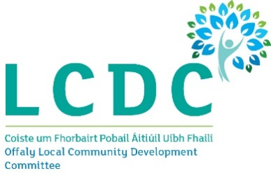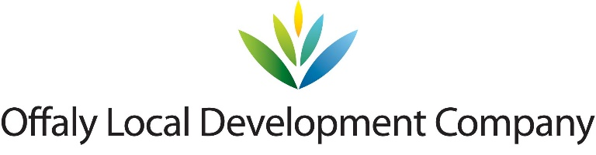

**Rural Development Programme 2014 – 2020**

**LEADER**

**Expression of Interest (EOI) Form**

**Rural Environment**

|  |
| --- |
| **NOTE:** This Expression of Interest (EOI) form must be completed as a pre-cursor to an application proper for funding under the Rural Development Programme 2014 – 2020 (LEADER). Failure to complete this form completely will result in a delay in dealing with your Expression of Interest and any further processing of any subsequent application arising therefrom for funding under RDP 2014-2020.  **Completion Guidance Notes:**   * Please complete this form in full. All fields are mandatory. * Please return this form to: Offaly Local Development Company, Millennium House, Main St, Tullamore, Co. Offaly * It can also be completed electronically and e-mailed to [rlennon@offalyldc.ie](mailto:rlennon@offalyldc.ie) or [info@offalyldc.ie](mailto:info@offalyldc.ie) * A hardcopy of this form can be obtained from Offaly Local Development Company:   Tel. 057 9322 850   * A Project Officer from Offaly Local Development Company will contact you when your **Expression of Interest Form** has been reviewed. * If you require assistance in completing this form please contact Offaly Local Development Company on the above phone number   **For further information on the Leader programme please visit**  [**http://drcd.gov.ie/about/rural/rural-development/leader/**](http://drcd.gov.ie/about/rural/rural-development/leader/)  **Closing Date for Expressions of Interest: 21st December 2018** |
| cid:image002.jpg@01D3653A.E4F47190 |

|  |  |  |
| --- | --- | --- |
| **Rural Development Programme (Leader) 2014 – 2020**  **Expression of Interest (EOI) Form**  **GENERAL INFORMATION**  **All Fields are mandatory and must be completed.** | | |
| \***Your Local Action Group (LAG) name:** | Offaly Local Community Development Committee | |
| \***Project Name / Title:** |  | |
| \***Promoter’s / Community Groups Name:** |  | |
| \***Promoters Lead / Main Contact Name:** |  | |
| \***Promoters Main Telephone No.:** |  | |
| \***Promoters E-mail Address:** |  | |
| \***Promoter’s Address Including EIRCODE** |  | |
| **Promoter Type:**  [Individual, Community Group, Organisation, Other]. | **Classification of Promoter:**  *Cross appropriate box and include copies of supporting governing documents with this application.*  Sole Trader  Community Council  Farmer(If Yes Herd No. is required below)  Trust  Formalised Community/Voluntary group  Partnership  Companies Limited by Guarantee  Limited Company  Designated Activity Company limited  Public Body  by shares  Registered Charity  Private Individual  Cooperative society registered under the Industrial & Provident  Societies Act | |
| **Project Focus:** | **Project Focus**  **Biodiversity**  **Water Quality**  **Renewable Energies** | |
| **Biodiversity** | **Habitat Development**  **Habitat Conservation**  **Amenity Development**  **Awareness Raising**  **Group Training**  **Biodiversity Planning**  **Information Dissemination** | |
| **Water Quality** | **Improving Water Quality**  **Developing or Conserving of water based habitats**  **Water conservation**  **Awareness Raising**  **Group Training**  **Information Dissemination** | |
| **Renewable Energies** | **Renewable Energy Upgrades**  **Installation of Renewable Energy Systems**  **Energy Auditing**  **Awareness Raising**  **Group Training**  **Information Dissemination** | |
| **Herd Number:** |  | |
| \***Tax Clearance Access Number**  **)Cert** |  | |
| \***Taxpayer Registration No.** |  | |
| **PROJECT INFORMATION** | | |
| **Project Address :** | |  |
| **Estimated Project Costs:**  [Total estimated costs] | |  |
| **Leader Funding Required for project:** | |  |
| **Projects Other Funding sources**  (If Any - Bank Loansetc.) | |  |
| **Please give a brief description of the proposed project** | | |

|  |  |  |
| --- | --- | --- |
| **Is this an Enterprise?**  **Yes / No** | **If Yes : Medium Small Micro** | **Is it an Existing Enterprise Yes / No** |

**For Office Use Only:**

**Signed for and on behalf of the Promoter / Group:**

I/ We confirm that the details supplied are true and correct to the best of my/our knowledge

Print Name: ________________________________

Signature: ____________________________________

Name in Block Capitals: _________________________

Date: __________/__________________/_________

Part or all of the information you provide will be held on computer and hard copy format. This information will be used for the administration of Expression of Interests and producing monitoring returns. LAG’s may share information with each other and government departments/agencies to enable them to prevent fraudulent applications or for detecting crime and to co-ordinate processing of complementary applications. It may also be subject to meeting obligations under the Freedom of Information Act as amended.

This policy does not affect your rights and your information will be held as prescribed under the Data Protection Acts 1988 and 2003.

**EOI Ref ID**: _____________________________ (Generated from RDP IT System)

**Call Type:** (Rolling / Time Limited) ________________________________.

**Main Programme Theme**: _____________________________________________________________

_________________________________________________________________________________

**Project Officer Signature: __________________________________**

**Printed name of Project Officer: ______________________________________**

**Date form Received from Promoter in Offaly Local Development Company**:

___________/__________________/________

**LAG Date Stamp:**